1. Create a script that asks for user name then send a greeting to him.

Command: vi hello.sh //write script

Chmod +x hello.sh // to make it execuatable

./hello.sh

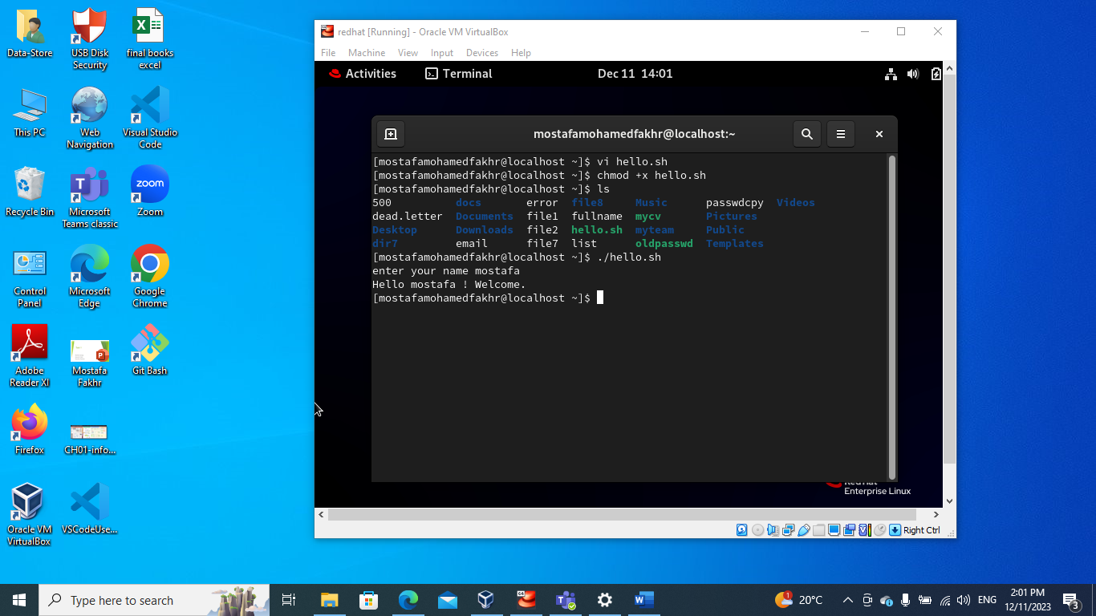

1. Create a script called s1 that calls another script s2 where:

Commands : vi s1.sh

Vi s2.sh

Then add inside the VI’s like the screen shot.

1. In s1 there is a variable called x, it's value 5. 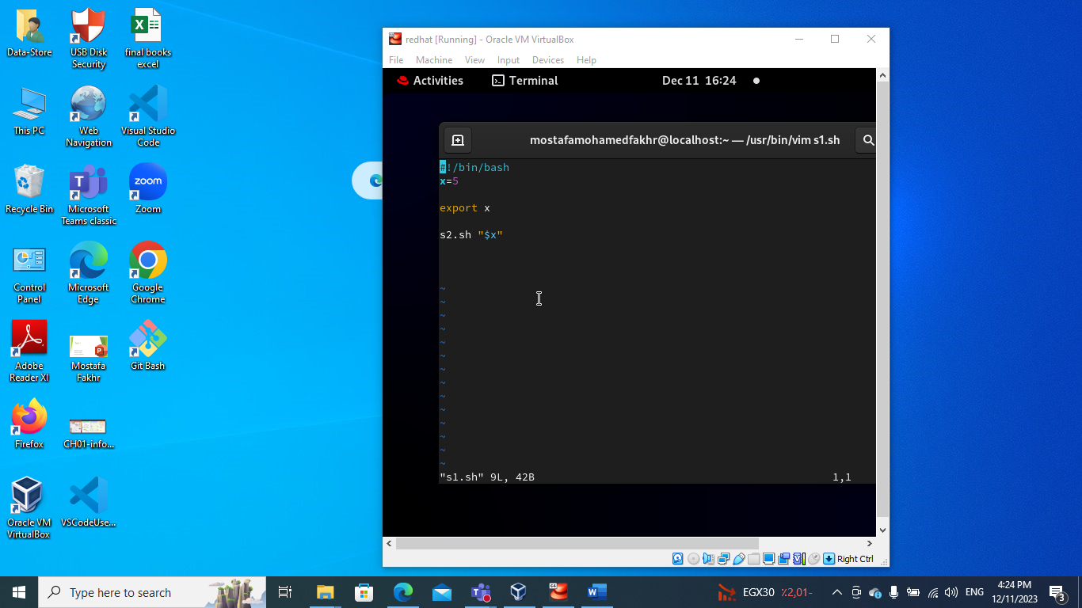
2. Try to print the value of x in s2 by two different ways.

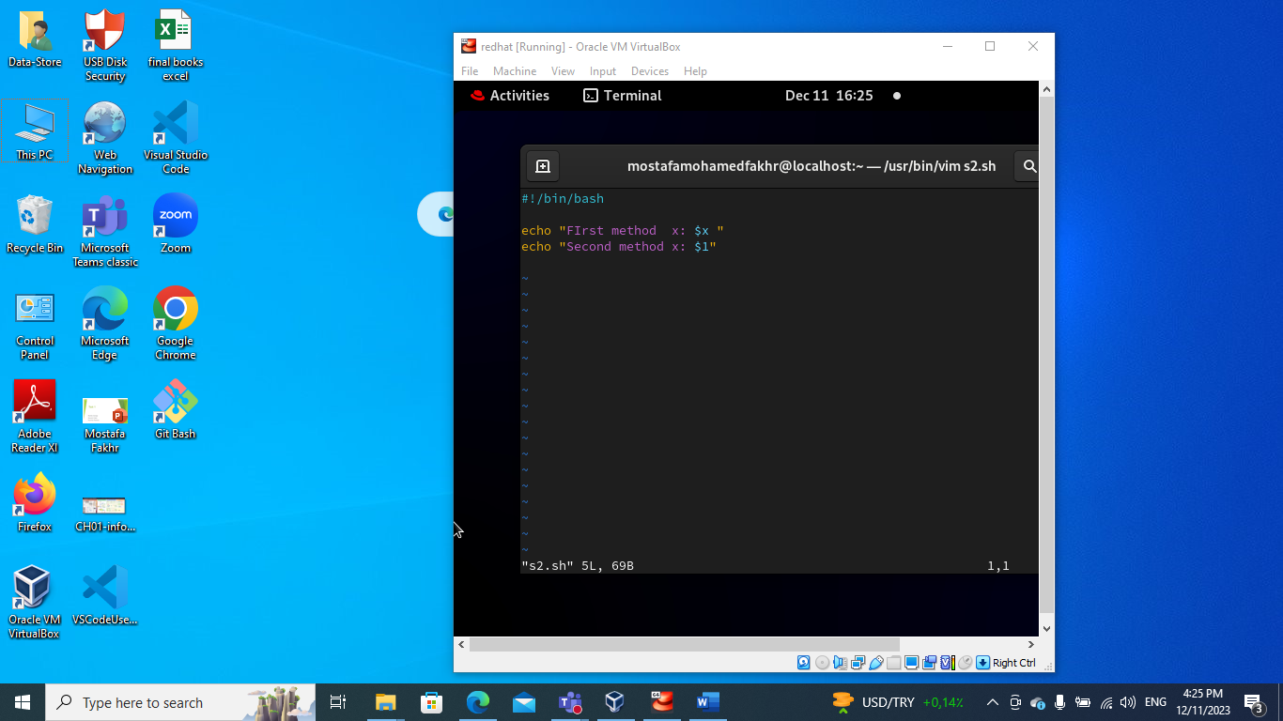

1. Create a script called mycp where:
2. It copies a file to another
3. It copies multiple files to a directory.

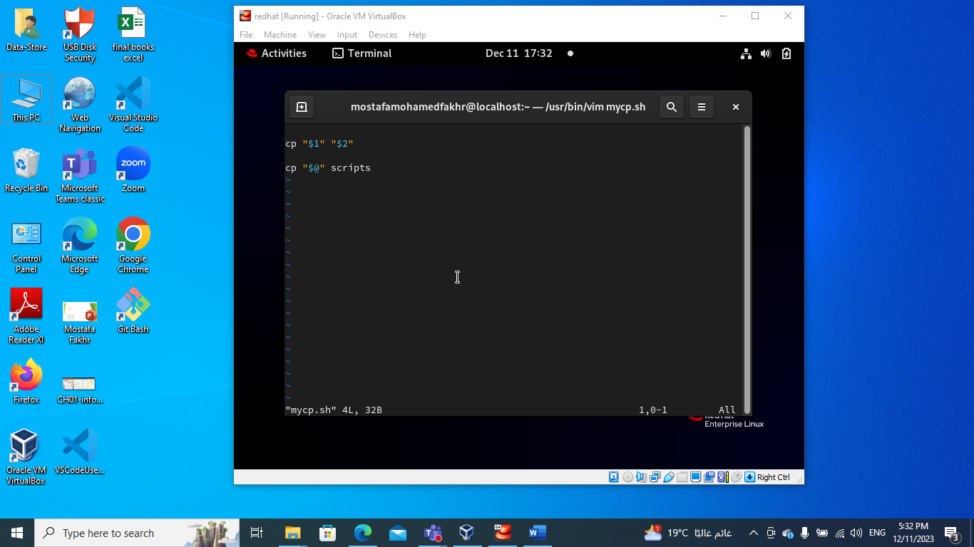

1. Create a script called mycd where:
2. It changed directory to the user home directory, if it is called without arguments.
3. Otherwise, it change directory to the given directory.

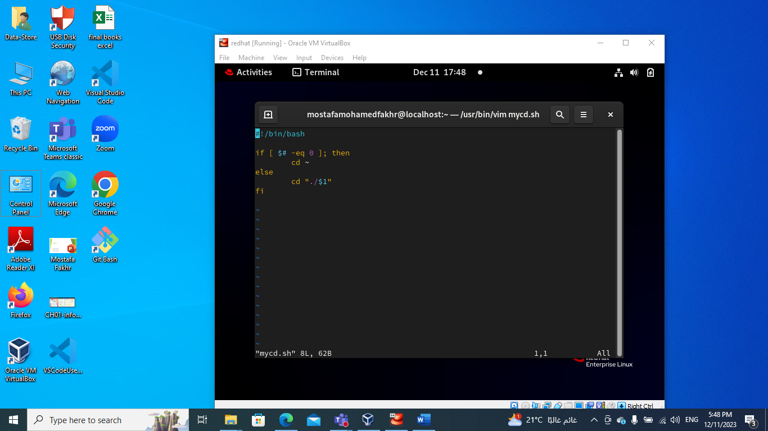

1. Create a script called myls where:
2. It lists the current directory, if it is called without arguments.
3. Otherwise, it lists the given directory.

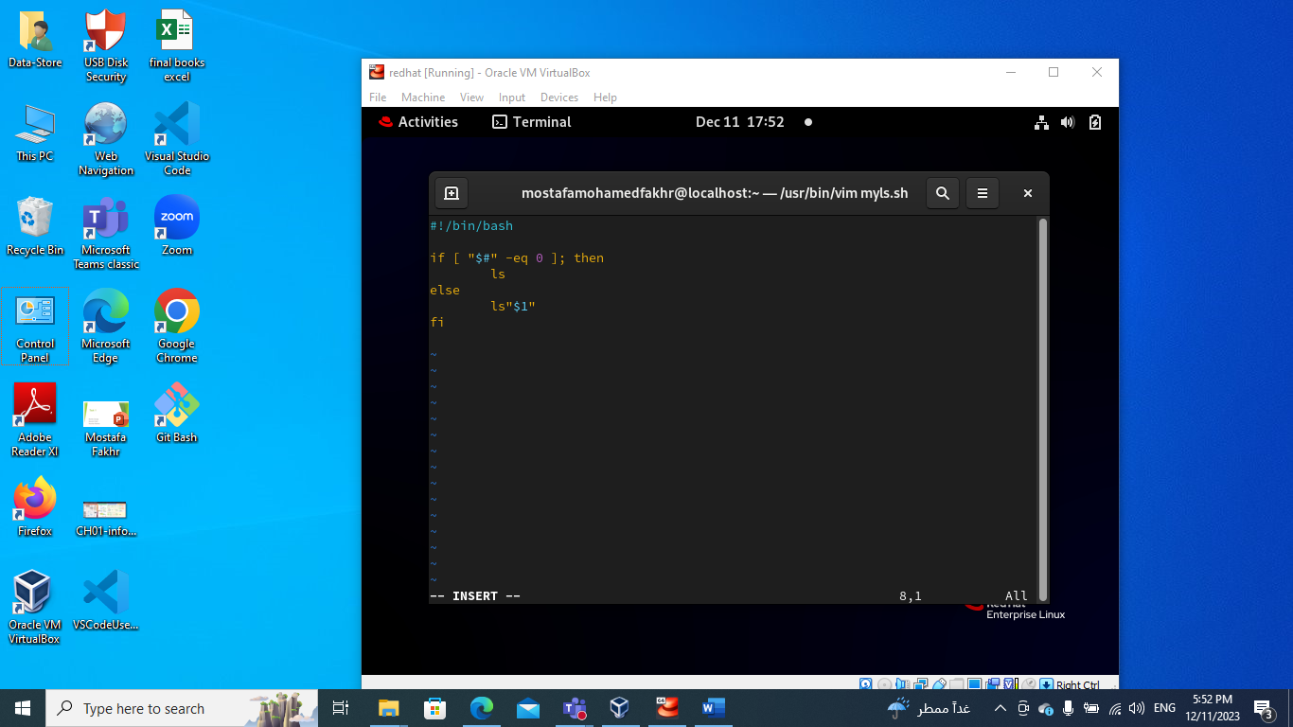

1. Enhance the above script to support the following options individually:
2. –l: list in long format
3. –a: list all entries including the hiding files.
4. –d: if an argument is a directory, list only its name
5. –i: print inode number
6. –R: recursively list subdirectories

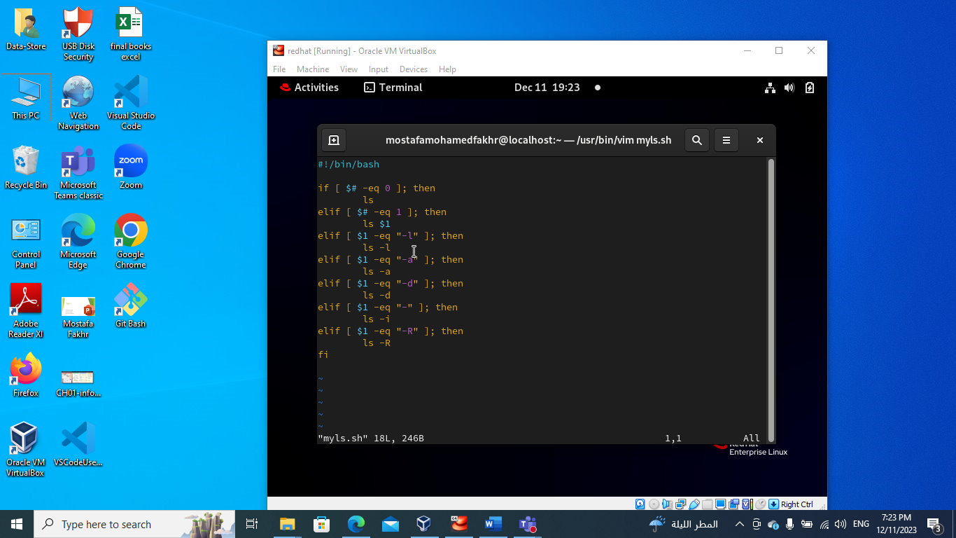

1. Create a script called mytest where:
2. It check the type of the given argument (file/directory)
3. It check the permissions of the given argument (read/write/execute)

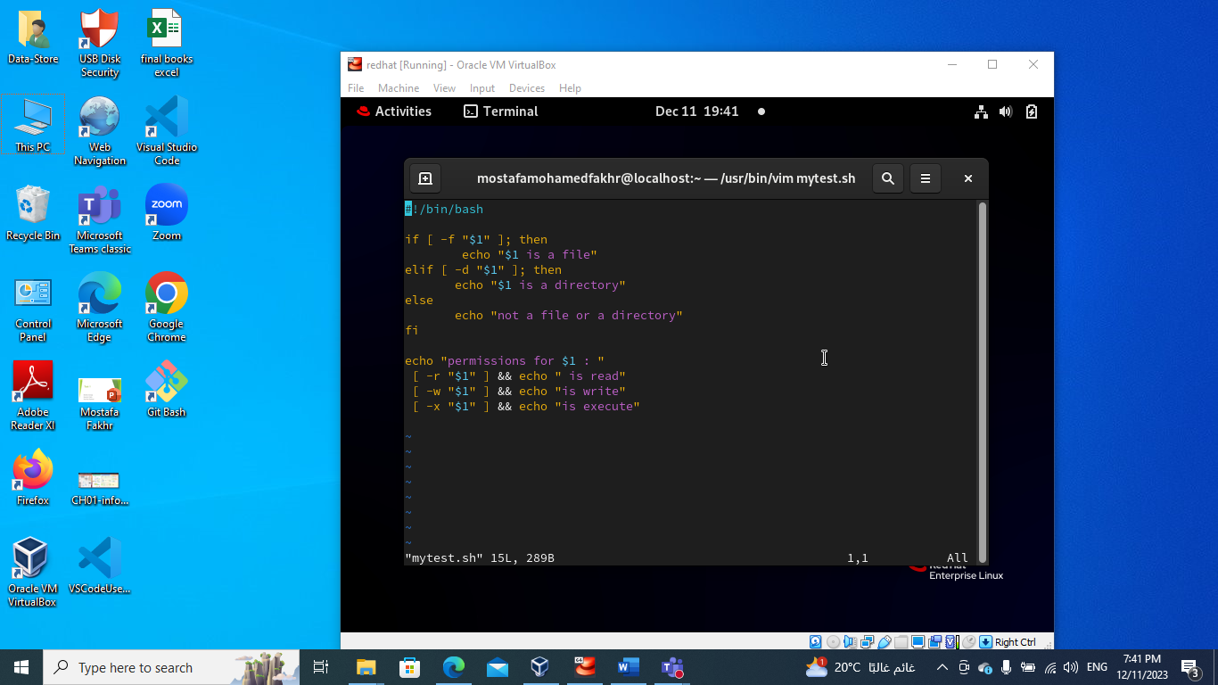

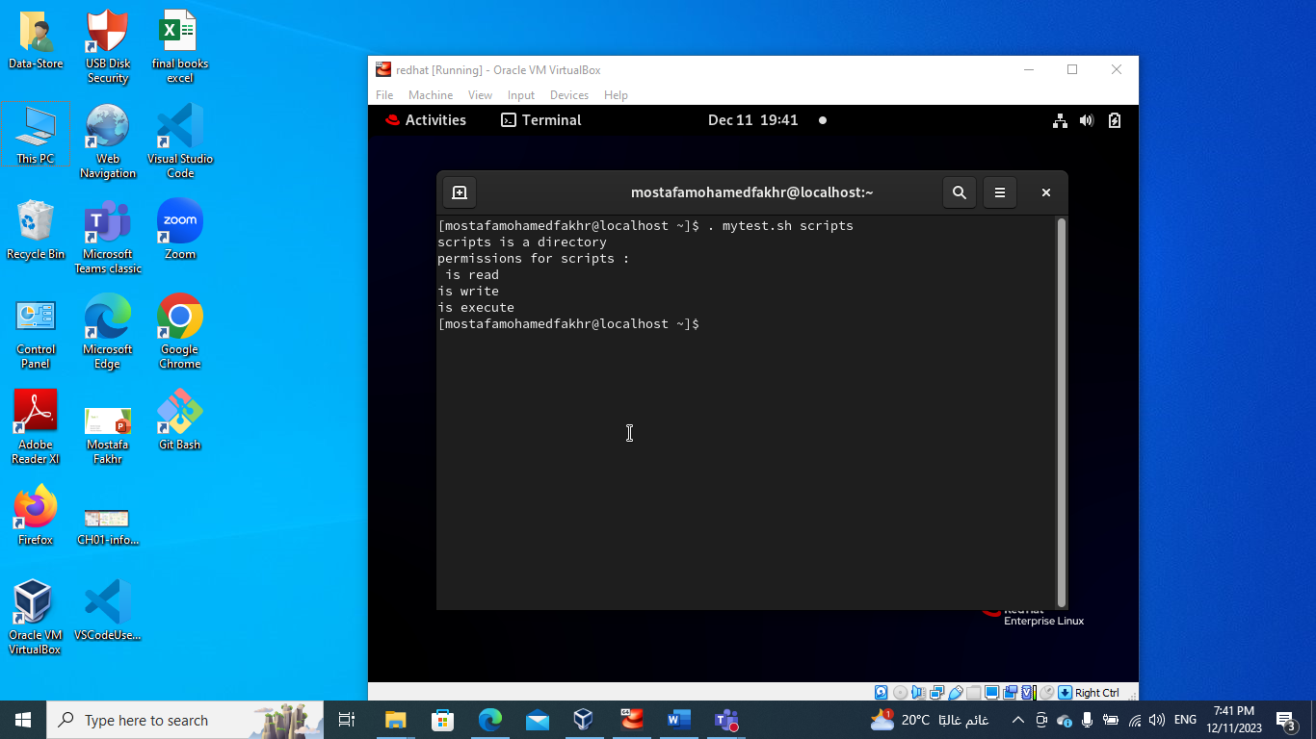

1. Create a script called myinfo where:
2. It asks the user about his/her logname.
3. It print full info about files and directories in his/her home directory
4. Copy his/her files and directories as much as you can in /tmp directory.
5. Gets his current processes status.

